**Summary of reference operating models for atlantic bluefin tuna**

Tom Carruthers[1], Doug Butterworth[2]

*SUMMARY*

To do last

*KEYWORDS*

*Management Strategy Evaluation, bluefin tuna, operating model, stock mixing*

# Introduction

A Management Strategy Evaluation (MSE, Butterworth 1999, Cochrane 1998) approach has been proposed for Atlantic bluefin tuna as a suitable framework for providing robust management advice consistent with the precautionary approach (GBYP 2017a). A principal task in the construction of an MSE framework is the development of operating models which represent credible hypotheses for population and fishery dynamics. Operating models are typically fishery stock assessment models which are fitted to data to ensure that model assumptions and estimated parameters are empirically credible (Punt et al. 2014, e.g. CCSBT 2011).

A general approach for testing MPs using MSE established two sets of operating models. The reference trials (‘Base case’) are considered to reflect the most plausible hypotheses and are the primary basis for identifying the best performing management procedure. Robustness trials are used to determine whether the management procedure behaves as intended in scenarios that are less likely.

In this paper the design of the reference set of operating models is described including the fit of these models to data. The operating models will be used to test a range of MPs that use indices of abundance to calculate TAC advice. The fit of the operating model to indices determines which indices should be included in MSE testing (i.e. what indices will be simulated and used to test MPs).

# Methods

Seasonal, spatial, multi-stock, age structured operating models were fitted to a wide variety of fishery dependent and independent data (see Carruthers et al. 2015a and CMG 2017). Such data included electronic tags, Task II catch rate and genetics data informing stock of origin (for a summary of these data see Carruthers et al. 2015b and GBYP 2017b).

A reference set of operating models was identified that spanned three main axes of uncertainty for Atlantic bluefin tuna: (1) future recruitment, (2) abundance, (3) age-at-maturity (spawning fraction) / natural mortality rate (see Tables 1 and 2 for the reference operating model design). Although this leads to 36 reference operating models in total, future recruitment scenarios are not applicable to model fitting. Consequently 12 unique model fits are presented here that cover factors 2 and 3 relating to abundance, maturity and natural mortality rate (the grey rows of Table 2).

# Results

**Model predictions of the base-case reference model #1**

Operating model #1 consists of the first levels of all factors, namely MPD ‘best’ estimate of abundance from the operating model (no additional priors), low age at maturity and high natural mortality rate. For this reference OM the model provides estimates of eastern area biomass that are similar to those of the VPA and Stock Synthesis (SS) assessments (Figure 1a). The trend however is more positive than those assessments and follows an upward trajectory from 1988 – 2015. The recent 3-fold increases in spawning biomass for the eastern stock that are estimated by the VPA assessment are not matched by the fitted OM #1.

OM #1 predictions of western spawning biomass are substantially higher on average than those of the VPA and SS assessments (around 39 000 tonnes from 1983-2015 as opposed to 28 000 t and 21 000t for the VPA and SS assessments respectively) (Figure 1a). The trend in spawning biomass is also different showing maximum biomass around 2003 rather than 2015 for the two assessments.

**Mimicking assessments: Factor 2, abundance**

OMs #4 and #7 are departures from OM #1 in that they use priors to specify similar mean abundance to the VPA assessments (OM #4, Factor 2 level 2) and increases in the Eastern SSB similar to the Eastern VPA assessment (OM #7, Factor 2 level 3). Figures 1b and 1c illustrate that these prior specifications were largely successful.

**All OM model estimates**

In general the 12 fitted operating models span a reasonably wide range of simulated stocks. MPD model estimates of FMSY ranged from 0.14 – 0.31 for the Eastern stock (Table 3) and 0.08-0.23 for the Western stock (Table 4). Stock depletion (SSB relative to unfished) ranged from 0.32 – 0.8 for the East stock and 0.3 – 0.45 for the Western stock.

With the exception of factor 2 level C, where increases in the East matched a prior, there was not a substantial different in the trajectories of the two stocks among the various operating models (Figure 4).

**Fit to indices of abundance**

The following indices did not show problematic patterns in residuals (Figure 2a and 2b) and are likely to be collected in the future.

Eastern, fishery dependent: JPN_LL_NEAtl2, MOR_POR_TRAP,

Eastern, fishery independent: FR_AER_SUV, MED_LAR_SUV, MED_AER_SUV

Western, fishery dependent: JPN_LL2, US_GOM_PLL2, US_RR_115_144, US_RR_66_114

Western, fishery independent: CAN_ACO_SUV, GOM_LAR_SUV

**Effect of OM factors**

In terms of the harvest rate at maximum sustainable yield (UMSY), the most important Factor was 3, which includes various scenarios for age at maturity and natural mortality rate. Lower natural mortality rates and older ages at maturity led to lower UMSY for both stocks. The impact of natural mortality rate (I vs III, II vs IV) was much higher on the UMSY estimates of the western stock however and made little different to UMSY estimates for the eastern stock.

Depletion estimates were also affected by the maturity and natural mortality rate with the most pessimistic estimates arising from the lower natural mortality rate scenarios II and IV.

# Discussion

Index selection

Robustness sets

# Acknowledgements

This work was carried out under the provision of the ICCAT Atlantic Wide Research Programme for Bluefin Tuna (GBYP), funded by the European Union, several ICCAT CPCs, the ICCAT Secretariat and by other entities (see: http://www.iccat.int/GBYP/en/Budget.htm). The contents of this paper do not necessarily reflect the point of view of ICCAT or other funders and in no ways anticipate ICCAT future policy in this area.

# References

ABT-MSE. 2017. Atlantic bluefin tuna management strategy evaluation: an R package. Available at: [accessed September 2017]

Butterworth, D.S., Punt, A.E., 1999. Experiences in the evaluation and implementation of management procedures. ICES J. Mar. Sci. 56, 985-998.

Carruthers, T.R., Kimoto, A., Powers, J., Kell, L., Butterworth, D., Lauretta, M. and Kitakado, T. 2015a. Structure and estimation framework for Atlantic bluefin tuna operating models. ICCAT SCRS/2015/179.

Carruthers, T.R., Powers, J., Lauretta, M., Di Natale, A., Kell, L. 2015b. A summary of data to inform operating models in management strategy evaluation of Atlantic bluefin tuna. ICCAT SCRS/2015/180.

CMG. 2017. Specifications for MSE trials for bluefin tuna in the North Atlantic. GBYP Core Modelling Group. ICCAT Atlantic Wide Research Programme for Bluefin Tuna. Available at: [accessed September 2017]

GBYP. 2017a. ICCAT Atlantic wide research programme for Bluefin Tuna. Available online at: http://www.iccat.int/GBYP/en/index.htm [accessed September 2017]

GBYP. 2017b. Data to inform operating models for North Atlantic bluefin tuna. ICCAT Atlantic Wide Research Programme for Bluefin Tuna. Available at: [accessed September 2017]

Cochrane, K L., Butterworth, D.S., De Oliveira, J.A.A., Roel, B.A., 1998. Management procedures in a fishery based on highly variable stocks and with conflicting objectives: experiences in the South African pelagic fishery. Rev. Fish. Biol. Fisher. 8, 177-214.

Punt, A.E., Butterworth, D.S., de Moor, C.L., De Oliveira, J.A.A., Haddon, M., 2016. Management strategy evaluation: best practices. Fish Fish. 17, 303–334, http://dx.doi.org/10.1111/faf.12104.

## Table 1. The factors and levels of the reference operating models.

|  |  |  |
| --- | --- | --- |
|  | West | East |
| Future recruitment | |  |
| 1 | Hockey-stick | 83+ B-H with *h*=0.98 |
| 2 | B-H with *h* estimated | 83+ B-H with *h*=0.70 |
| 3 | Hockey-stick changes to  B-H after 10 years | 83+ B-H with *h*=0.98 changes to 50-82 B-H with *h*=0.98 after 10 years |
| Abundance | |  |
| A | Best estimate | |
| B | East-West area spawning biomass matches VPA assessment | |
| C | Recent eastern area SSB increases 3x to match VPA assessment | |
| Maturity (both stocks) | | Natural Mortality (both stocks) |
| I | Younger | High |
| II | Younger | Low |
| III | Older | High |
| IV | Older | Low |

## Table 2. The design of reference operating models. Note, only future recruitment level 1 are presented in this paper (grey shaded rows) since future recruitment scenario is unrelated to fitting of operating models.



**Table 3**. Operating model estimates (maximum posterior density) for the Eastern stock.

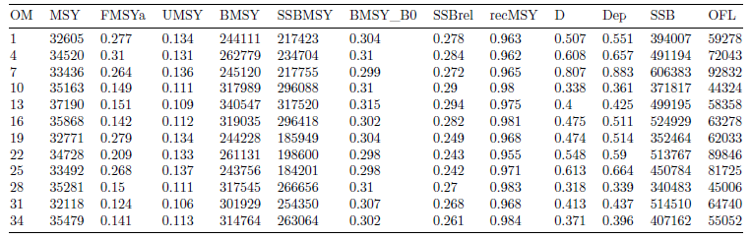

**Table 4**. Operating model estimates (maximum posterior density) for the Western stock.

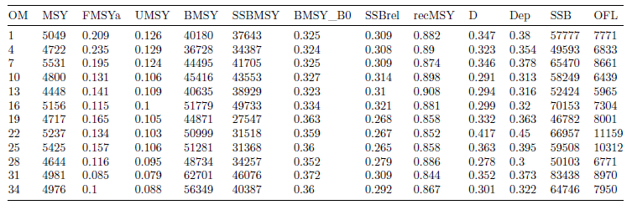

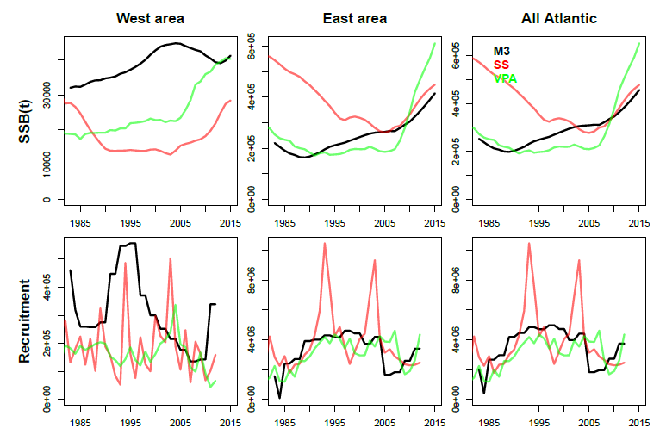

**Figure 1a.** Similarity of M3 operating model estimates (OM #1) with Western and Eastern assessments (2017).

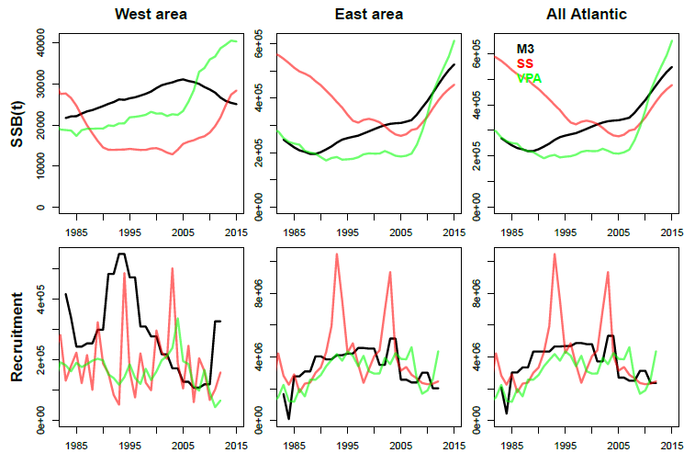

**Figure 1b.** Similarity of M3 operating model estimates (OM #4) with Western and Eastern assessments (2017). This operating model differs from OM#1 (Figure 1a above) in that is level B for factor 2 (abundance) and the mean spawning biomass levels in the East and West areas have an informative prior that matches the VPA assessments.

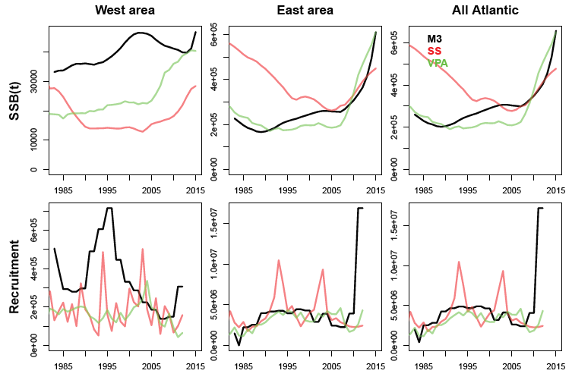

**Figure 1c.** Similarity of M3 operating model estimates (OM #7) with Western and Eastern assessments (2017). This operating model differs from OM#1 (Figure 1a above) in that is level C for factor 2 (abundance) and the trend in Eastern areas SSB over the last 9 years has an informative prior to match the three fold increase in the Eastern VPA assessment.

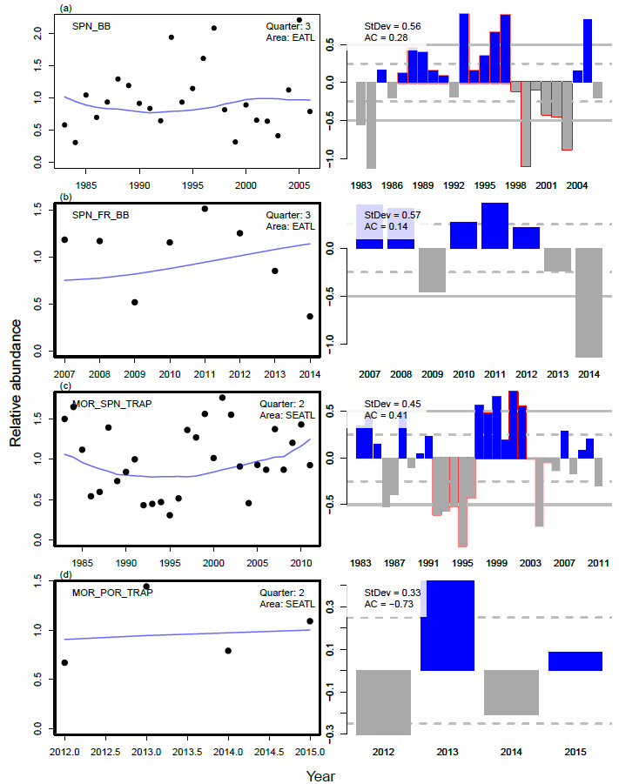 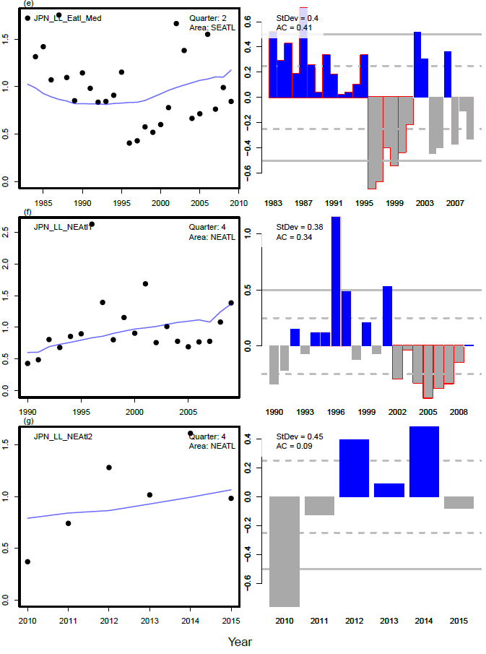

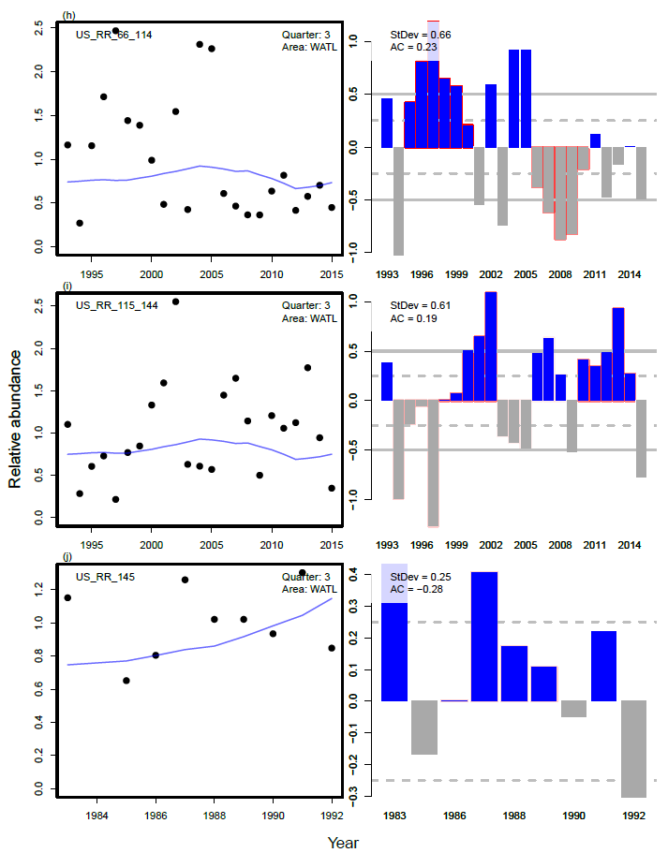 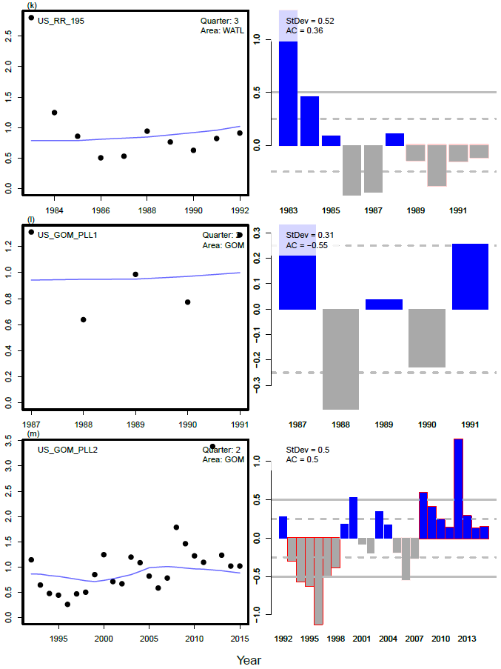

**Figure 2a.** Fit of OM#1 to stock assessment CPUE indices.

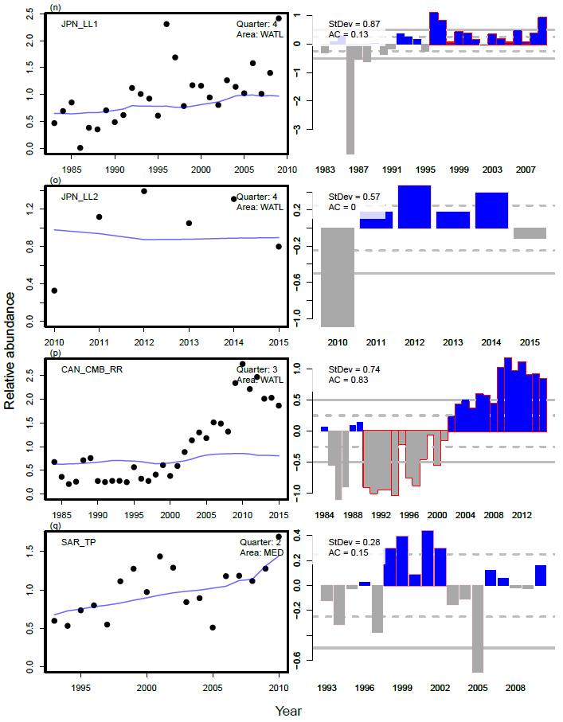 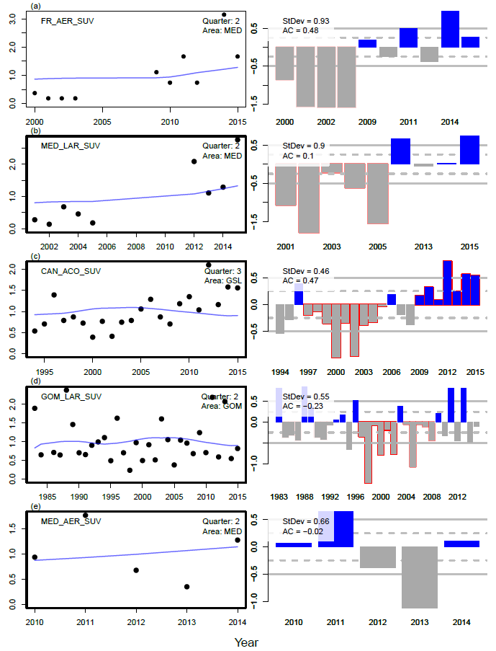

**Figure 2b.** Fit of OM#1 to stock assessment CPUE indices and fishery independent indices.

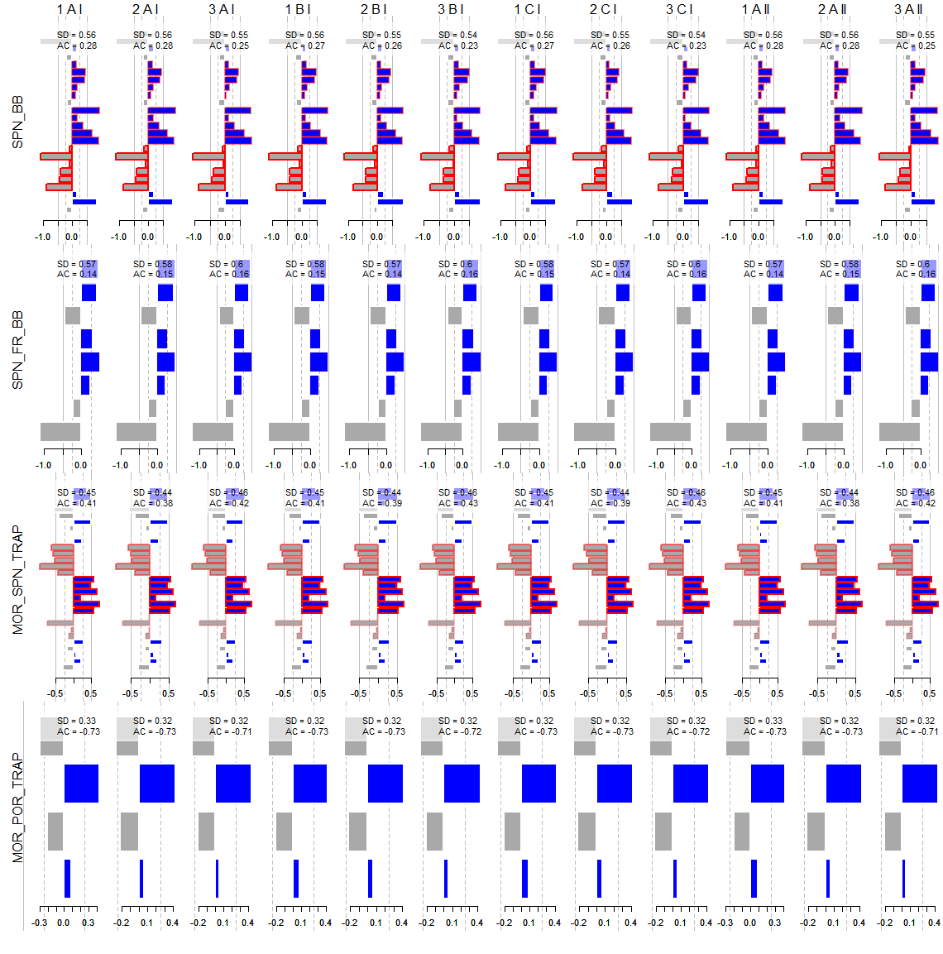

**Figure 3a**. Residuals for all operating model fits (columns) to various assessment indices (rows)

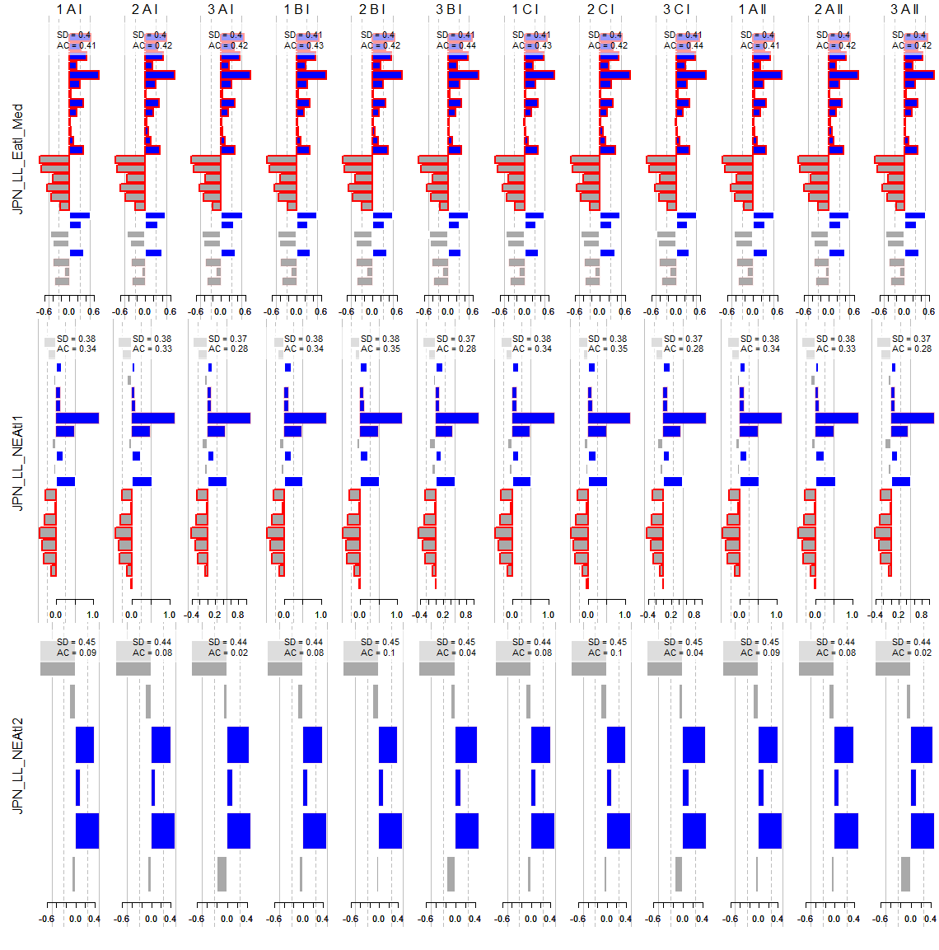

**Figure 3b**. Residuals for all operating model fits (columns) to various assessment indices (rows)

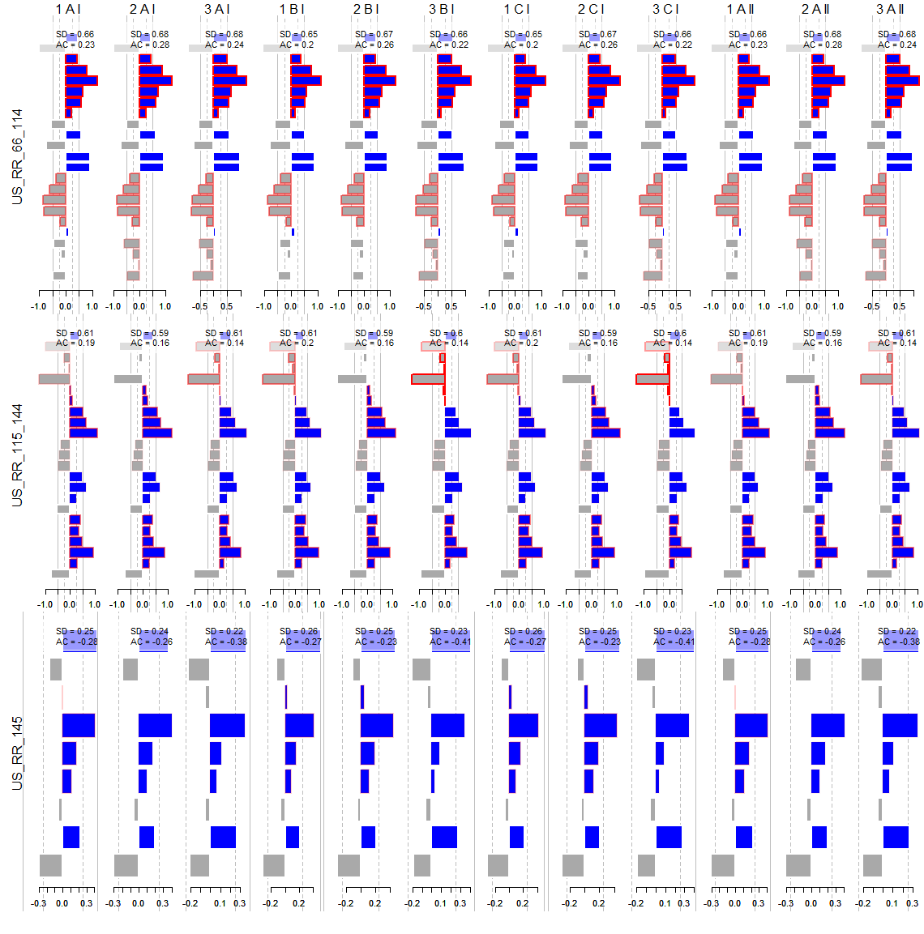 **Figure 3c**. Residuals for all operating model fits (columns) to various assessment indices (rows)

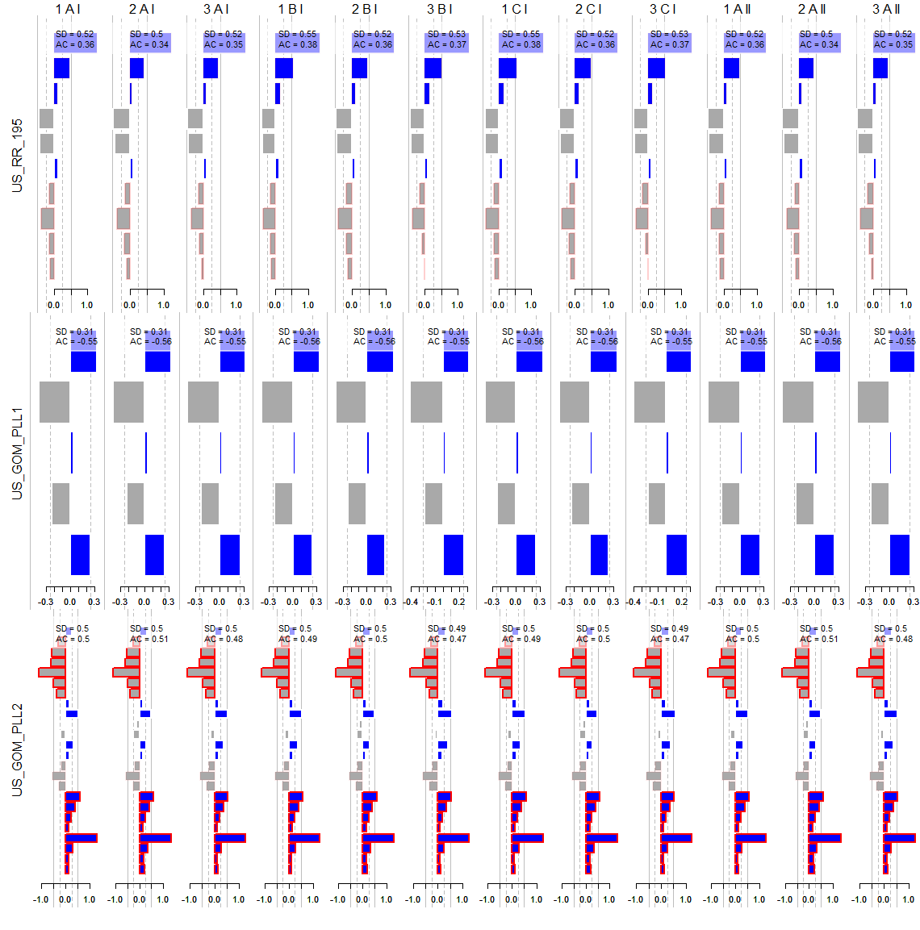

**Figure 3d**. Residuals for all operating model fits (columns) to various assessment indices (rows)

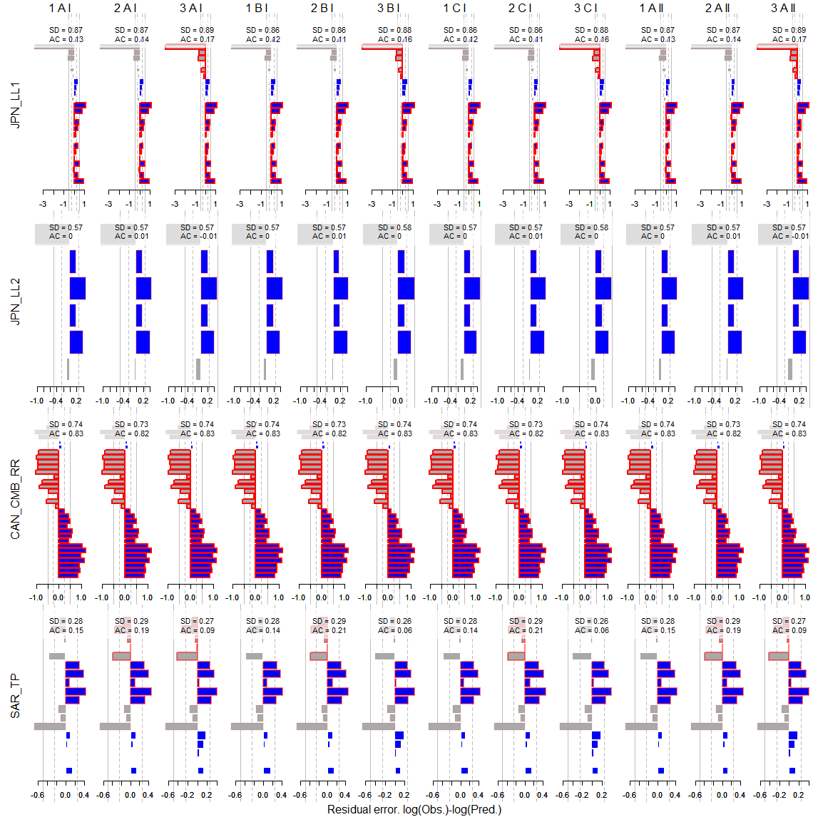

**Figure 3e**. Residuals for all operating model fits (columns) to various assessment indices (rows)

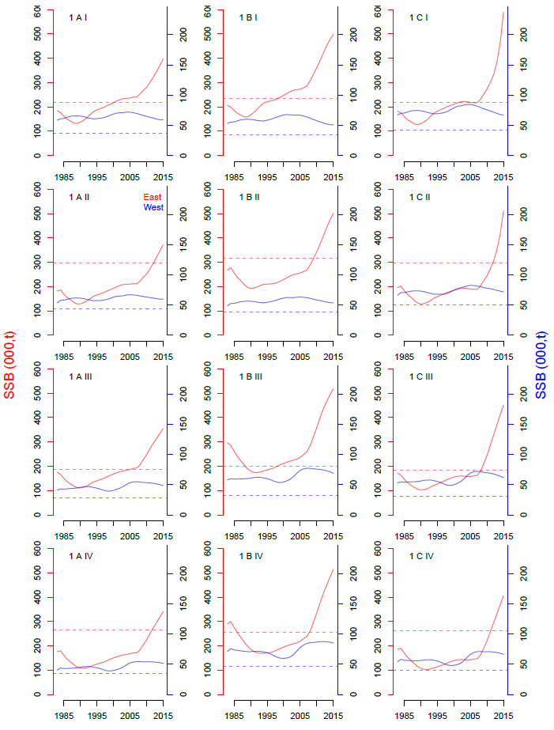

**Figure 4.** Predicted spawning biomass (East and West stocks) for each operating model (maximum posterior density estimates)

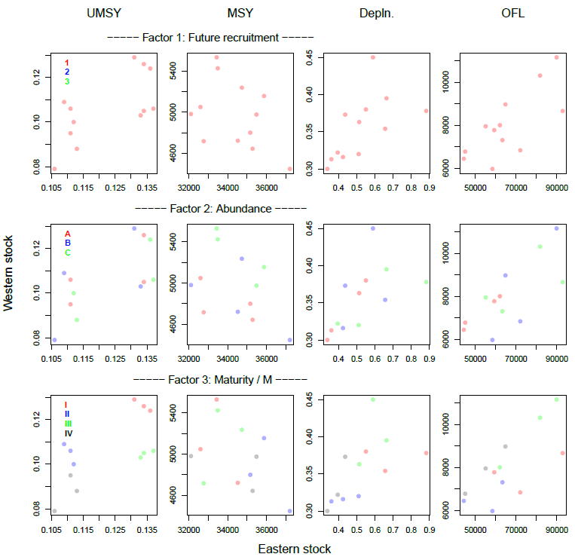

**Figure 5**. The effect of factors and their levels on OM model predictions. Each panel shows model estimates for the Eastern (x axis) and Western (y axis) stocks for four quantities, harvest rate at MSY (UMSY), maximum sustainable yield (MSY), stock depletion (current SSB relative to unfished, ‘Depln’) and the over fishing limit (UMSY multiplied by current vulnerable biomass,

1. IOF, 2202 Main Mall, University of British Columbia, Vancouver, B.C., Canada, V6T 1Z4. [t.carruthers@oceans.ubc.ca](mailto:t.carruthers@oceans.ubc.ca)
2. Dpt. Maths and Applied Maths, University of Cape Town, Rondebosch 7701, South Africa. doug.butterworth@uct.ac.za